Earth Science Name_______________________________
Finding the Epicenter of an Earthquake Period_______ Date___________________
You know that numerous recording stations can record the arrival of P and S-waves from any earthquake that occurs in most places around the world. The P-waves arrive first because they travel the fastest, followed by the slower S-waves. By using the P-S wave time difference, you’ve learned to calculate the distance a recording station is from the earthquake epicenter. Remember, the epicenter is the point on the Earth’s surface directly above the focus of the earthquake, or place where the rocks moved.
So, if you know that a particular recording station is a certain distance from the earthquake, can you pinpoint the epicenter? If you think about it, a given distance from the epicenter, say 500 km, means that the recording station is 500 km from the epicenter. If you used the map scale and marked distances that were 500 km from the recording station, you’d be able to draw a circle around the recording station. However, you wouldn’t know exactly where the earthquake happened! So … how do geologists use seismograms to locate the epicenter of an earthquake?
By the end of the activity, you’ll be an expert at finding earthquake epicenters and you’ll be qualified to work for the U.S. Geological Survey’s National Earthquake Information Center in Golden, Colorado. Have fun finding the epicenter of this earthquake.
Procedure:
Part A: Determining Time and Distance
- Study the five seismograms for this activity. These are more difficult to interpret than others you have seen as they are closer to real seismograms. For this reason the P- and S-wave arrivals have been marked.
- Look at the horizontal scale that represents arrival times. Each vertical line represents 10 seconds. Because you are interested only in the difference in arrival times, choose any convenient vertical line to represent t = 0s. Also notice how a few vertical lines appear to be missing. Real seismograms often use a different color once each minute; however, some colors (such as light blue) do not photocopy well.
- Look at the seismogram for TRYN (recording stations often use abbreviations for their city). If we choose the vertical line immediately before the earthquake hits as t = 0s, then the P-waves arrived at approximately 2 seconds and the S-waves arrived at 31 seconds. The P-S arrival difference is approximately 29 seconds. For best results, record all times to the nearest second.
- Use the P- and S-Wave Arrival Time Graph to estimate the distance to the epicenter. For Station TRYN, the distance should be approximately 230km.
- Complete the data table for the other four stations.
Part B: Finding the Epicenter (Triangulation)
- Using the scale on your map, adjust the radius of your compass to represent the distance to Station TRYN (approximately 230km).
- Place the pointy tip of your compass on Station TRYN and lightly draw a circle. A light touch is key to the successful use of our compasses as they do not hold their settings well.
- Repeat the previous two steps for the other four stations.
- Locate and label the epicenter on your map. (A labeled star works well.)
Part C: Analysis
- How does finding the time difference between the arrival of P- and S-waves help you find the epicenter for an earthquake?
- Why can’t you find the epicenter for an earthquake using data from only two stations?
- What is the minimum number of seismograms required to triangulate (find) the epicenter for an earthquake on a map? Explain.
- What is the latitude and longitude for the epicenter of this earthquake.
- Which recording station(s) probably had the most damage from this earthquake? Give two reasons why.

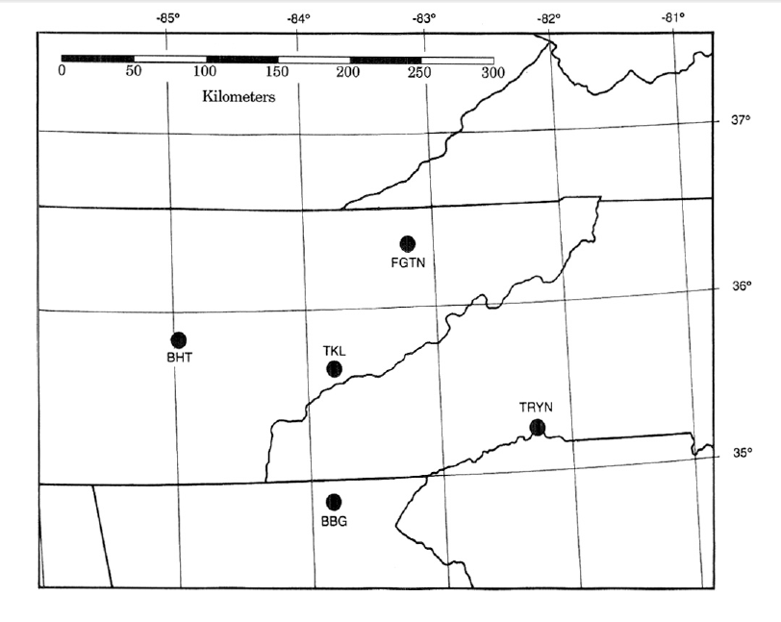
Finding Time & Distance for an Earthquake

Station | Time Difference  (T_{s} – T_{p}) | Distance
TRYN

TKL

FGTN

BBG

BHT

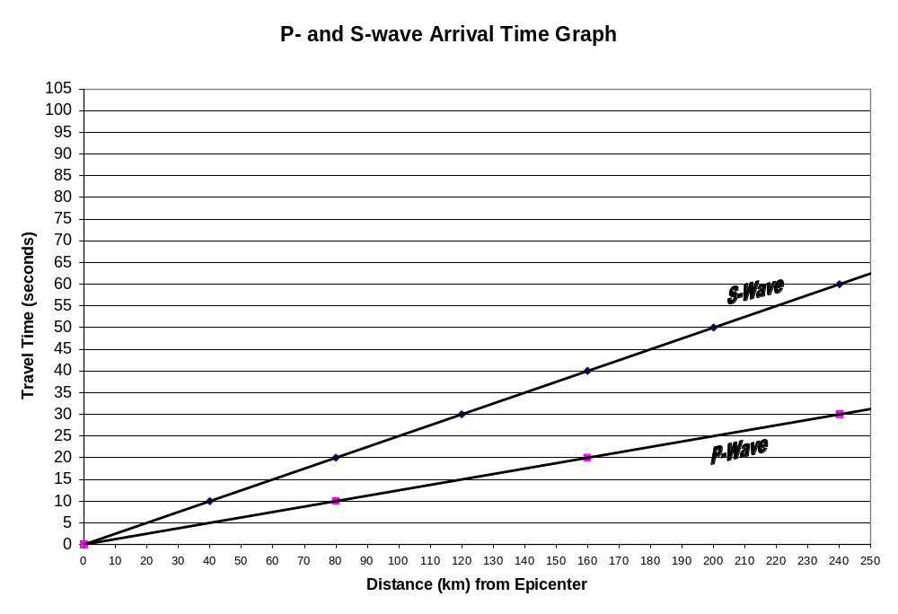
Sample Seismograms
(Modified from Seismic Sleuths AGU/FEMA)



